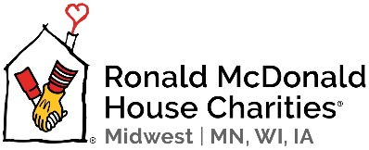

Barbara Henoch
Volunteer Scholarship Program

Application Form

(The selection committee reserves the right to deny any application which does not meet selection criteria.)

Name
Street Address
City |  |  | State |  | Zip
Phone |  |  | E-mail

High School: |  |  |  |  |  | Graduation Date:
Post-Secondary: |  |  |  |  |  | Graduation Date:
Post-Secondary School desired:
 |  |  |  | (college, university, technical college)
Location:
Have you been accepted: |  |  | € Yes € No |  | Enrollment Date:

What is your intended course of study?
Anticipated graduation/completion date? ____________________

- When did you begin volunteering at the Ronald McDonald House?
Total number of volunteer hours:
- Please share a specific activity or memory from your volunteer experience at the Ronald McDonald House that relates to the mission of the House.
- How has your volunteer experience at the Ronald McDonald House influenced your life outside of the House?
- Describe your Ronald McDonald House involvement. Why you first got involved, what role(s) you fulfilled (ie: HouseWarmer, House Dinner Host, Gardening Angel, Ambassador, etc.), and why you continued volunteering:

- Describe your community involvement: (clubs, volunteer, work, etc)
- How would receiving this scholarship impact you?

Please include a one-page essay along with your application telling us:
- why you would like to continue your education
- your academic goals
- what you would like to do in the future and
- why you are a suitable candidate for this volunteer scholarship

Questions can be directed to Katie Arnott, Volunteer Director
507-252-2161 ♥ 507-252-2160 (fax) ♥ karnott@rmhmn.org

Please return completed application and essay to:
RMHC Midwest | MN, WI, IA ♥ 850 2nd St SW ♥ Rochester, MN 55902

